**Software Engineering Project**

**Electronic Health Record System**

05120000238 - Murat Can ÜSTE

05120000251 - Nagihan KALAYCI

05130000247 - Bilge ULUSAY

Contents

**1. Gantt Chart of the Project Plan3**

**2. Network Diagram of the Project Plan12**

**3. Division of Labor within the Team25**

**4. Risk Analysis29**

**1. Gantt Chart of the Project Plan**

*Overview*



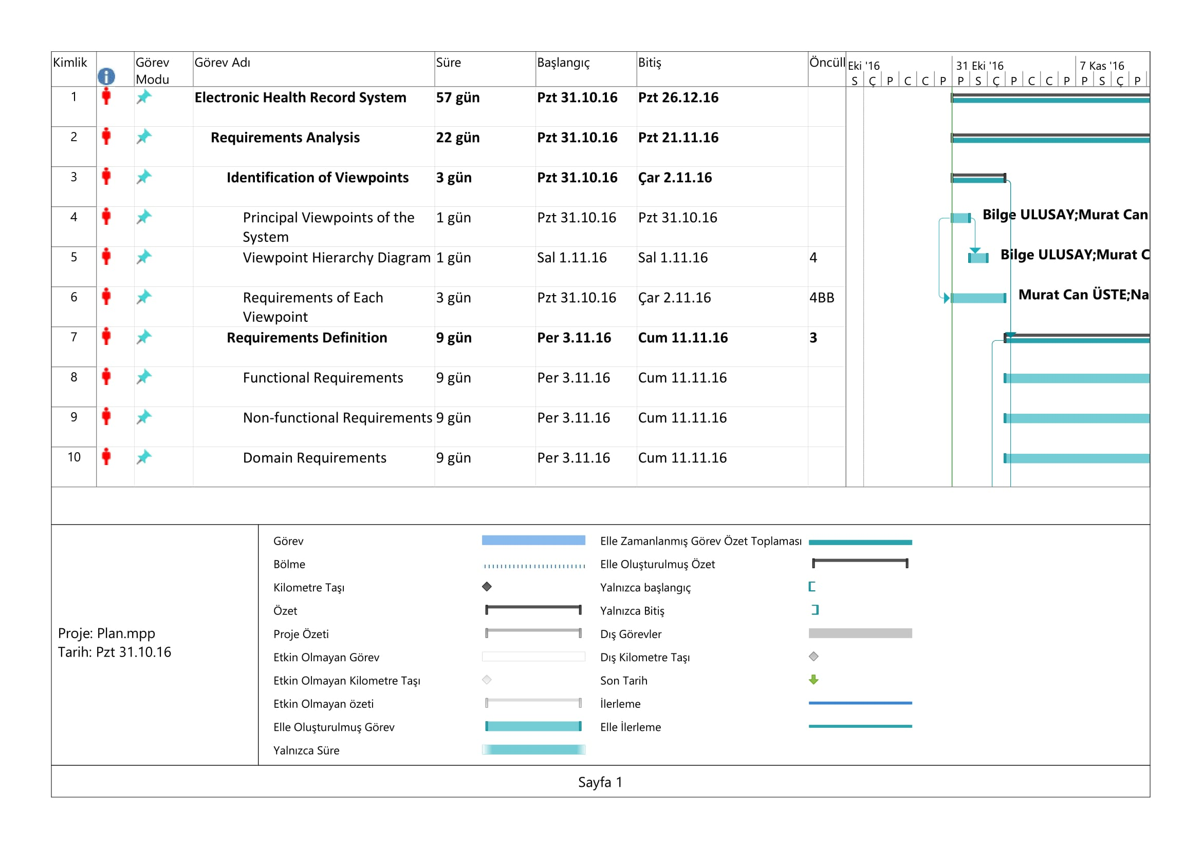

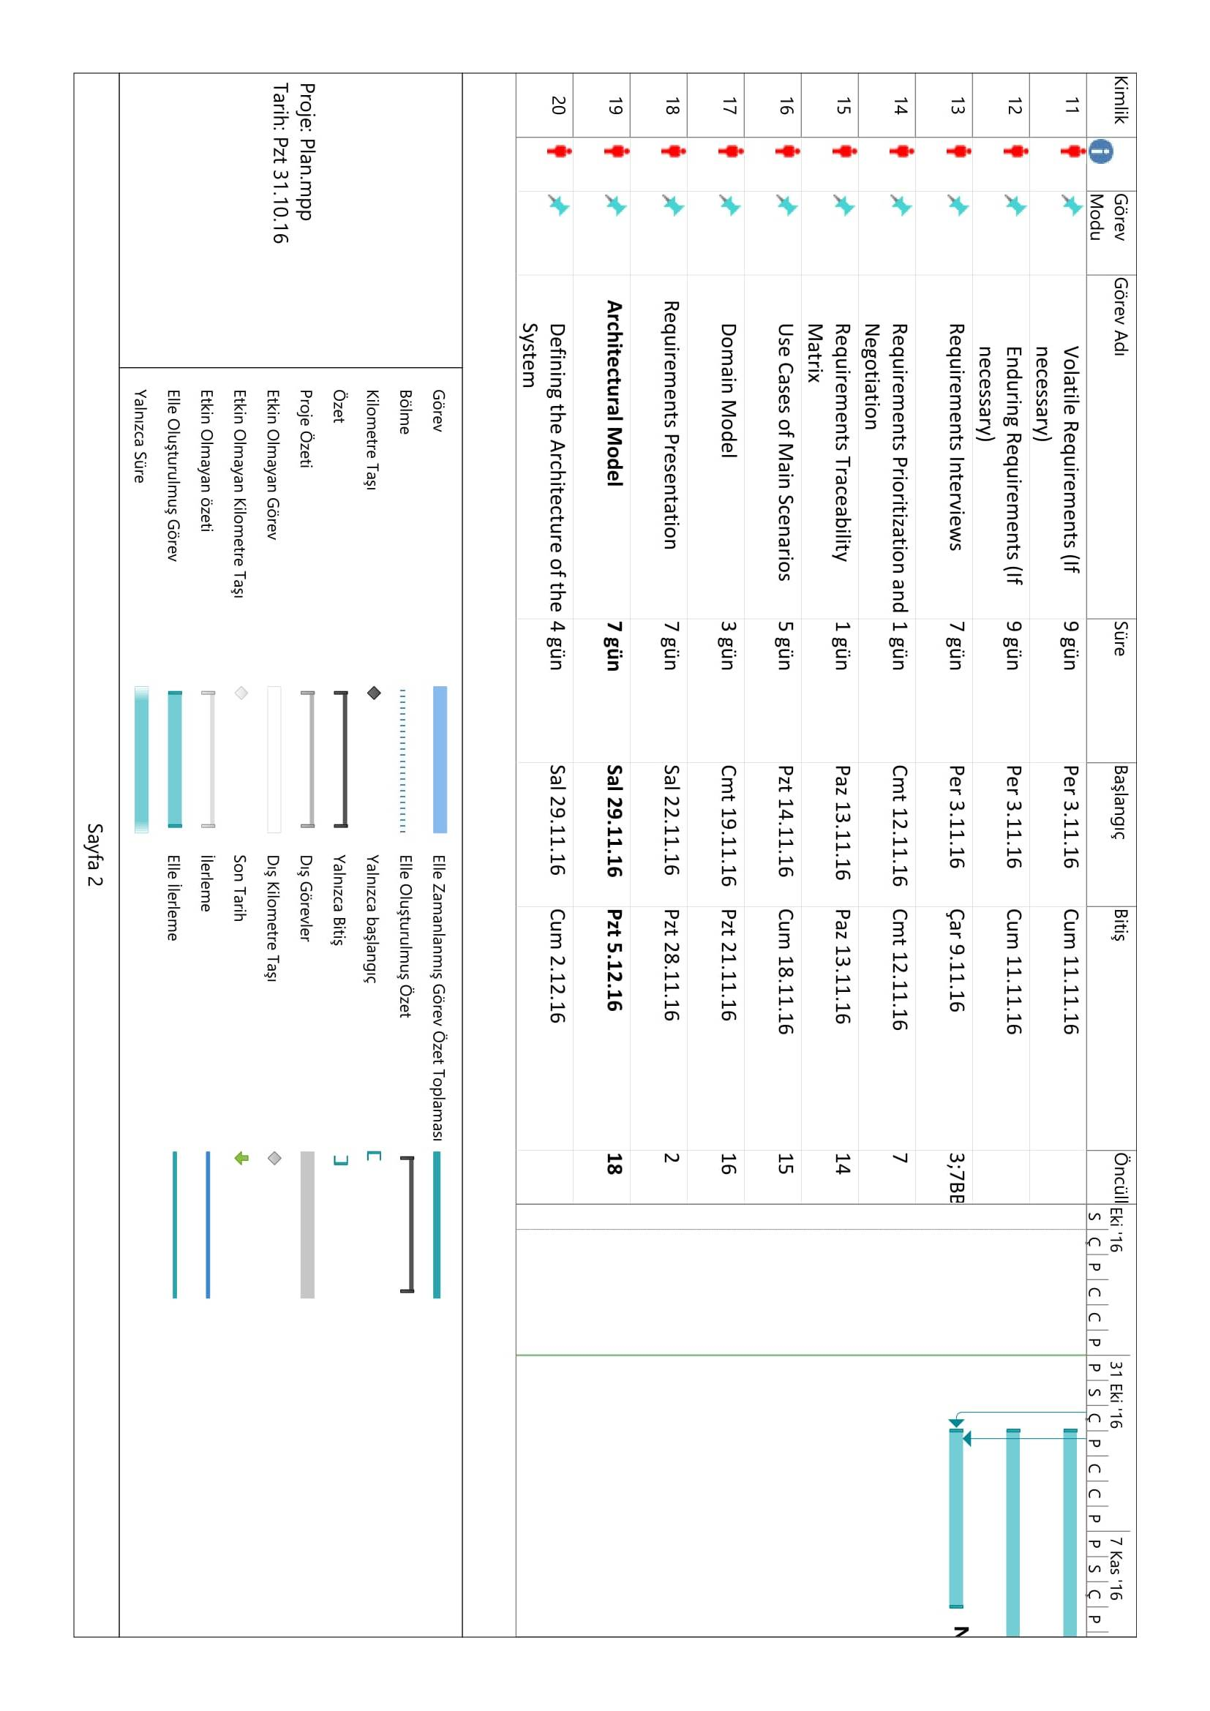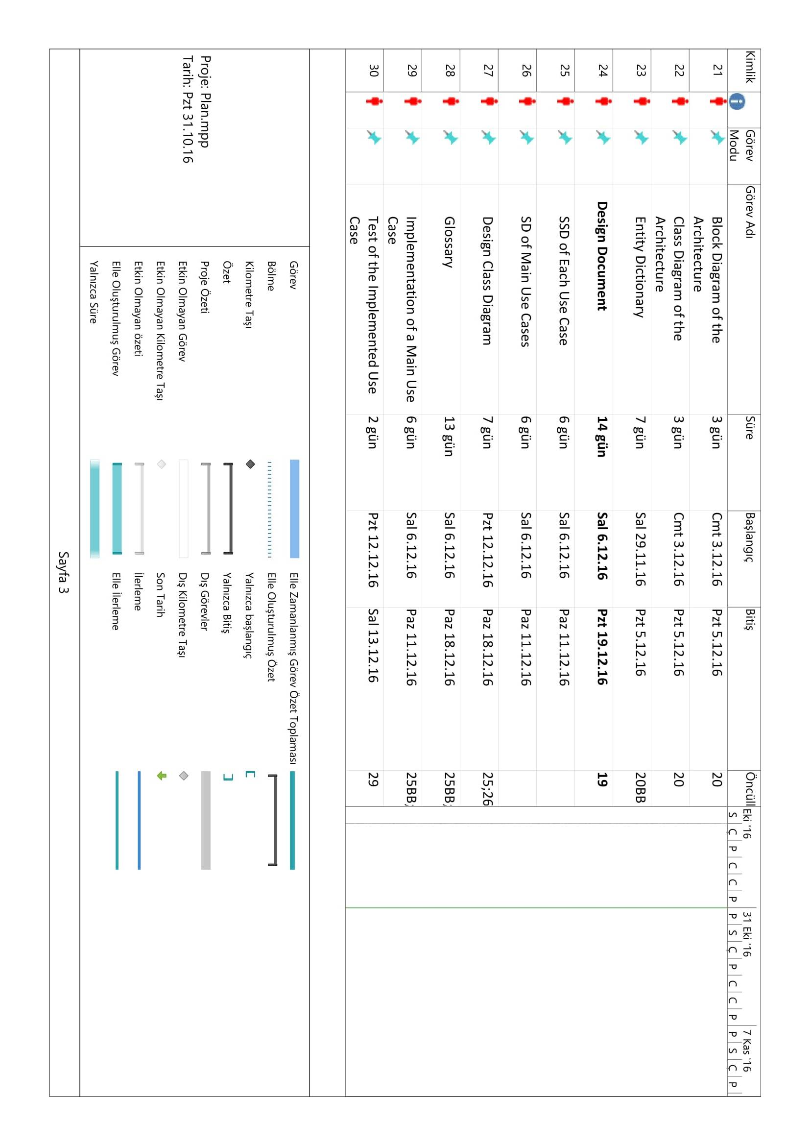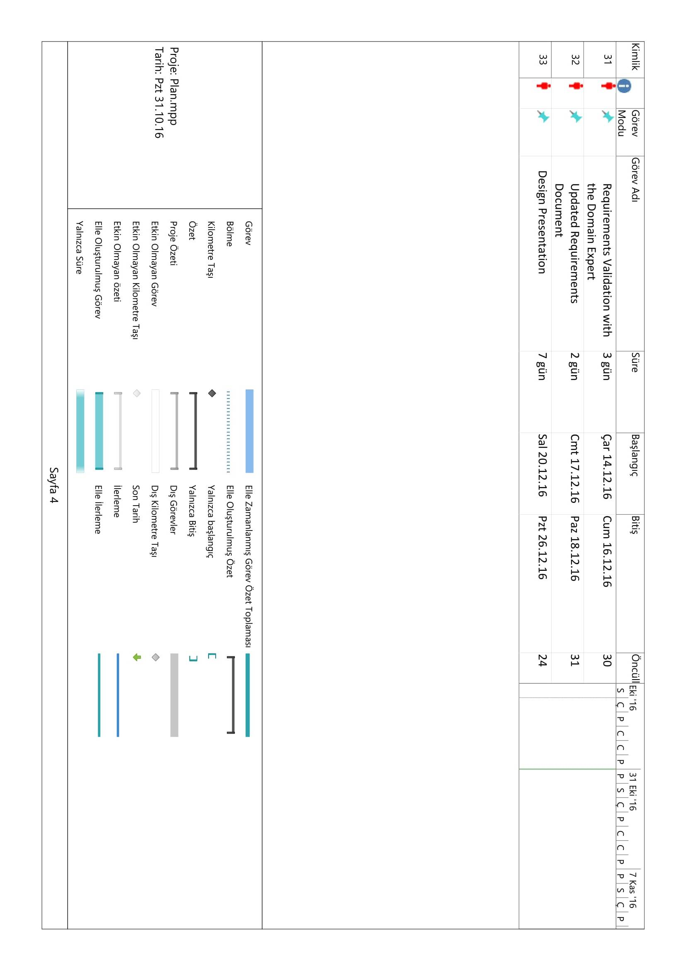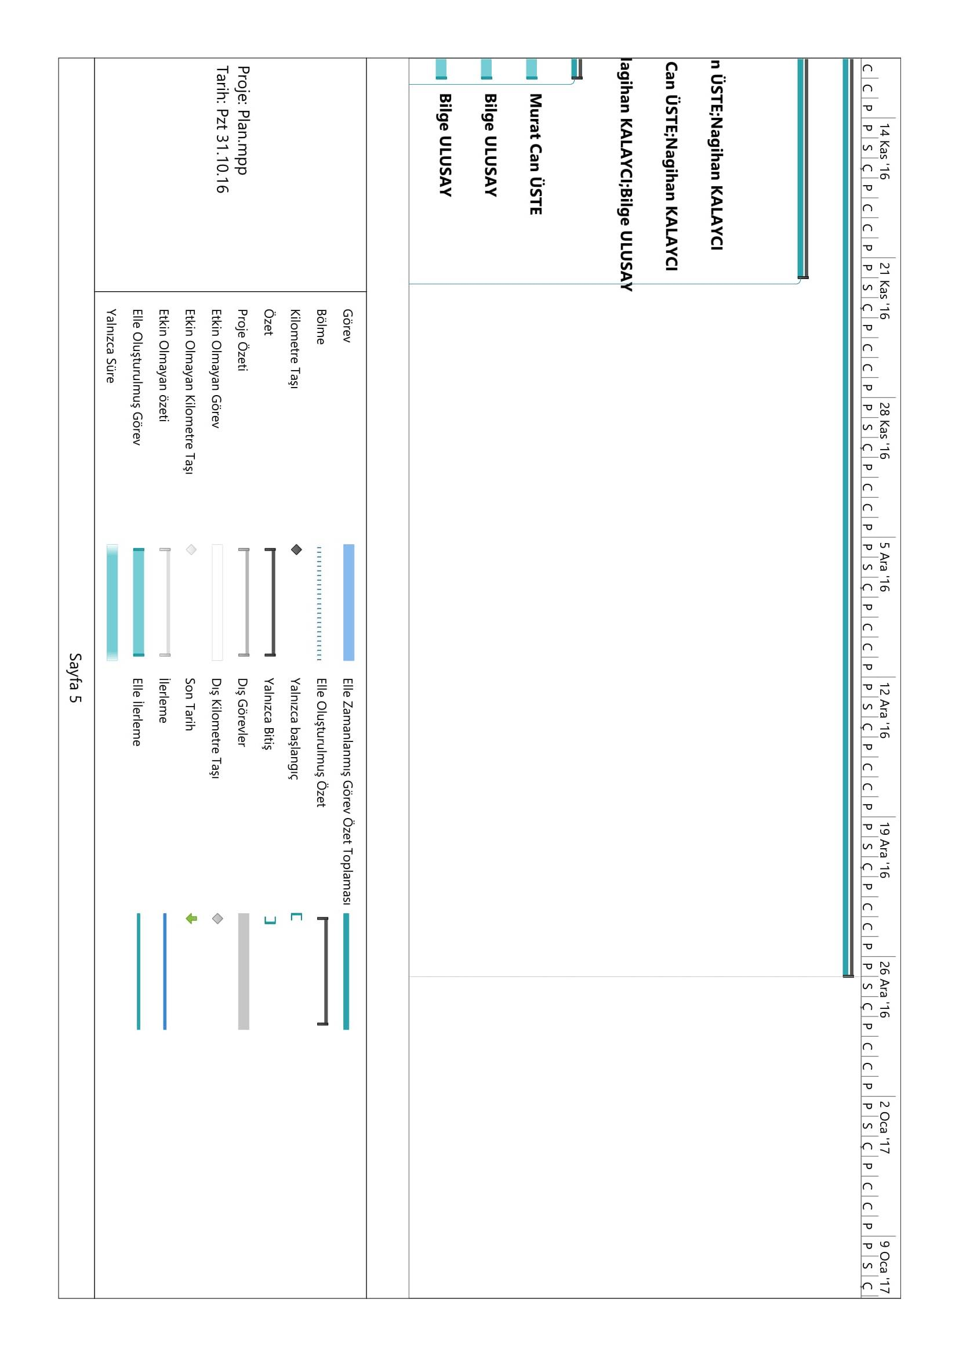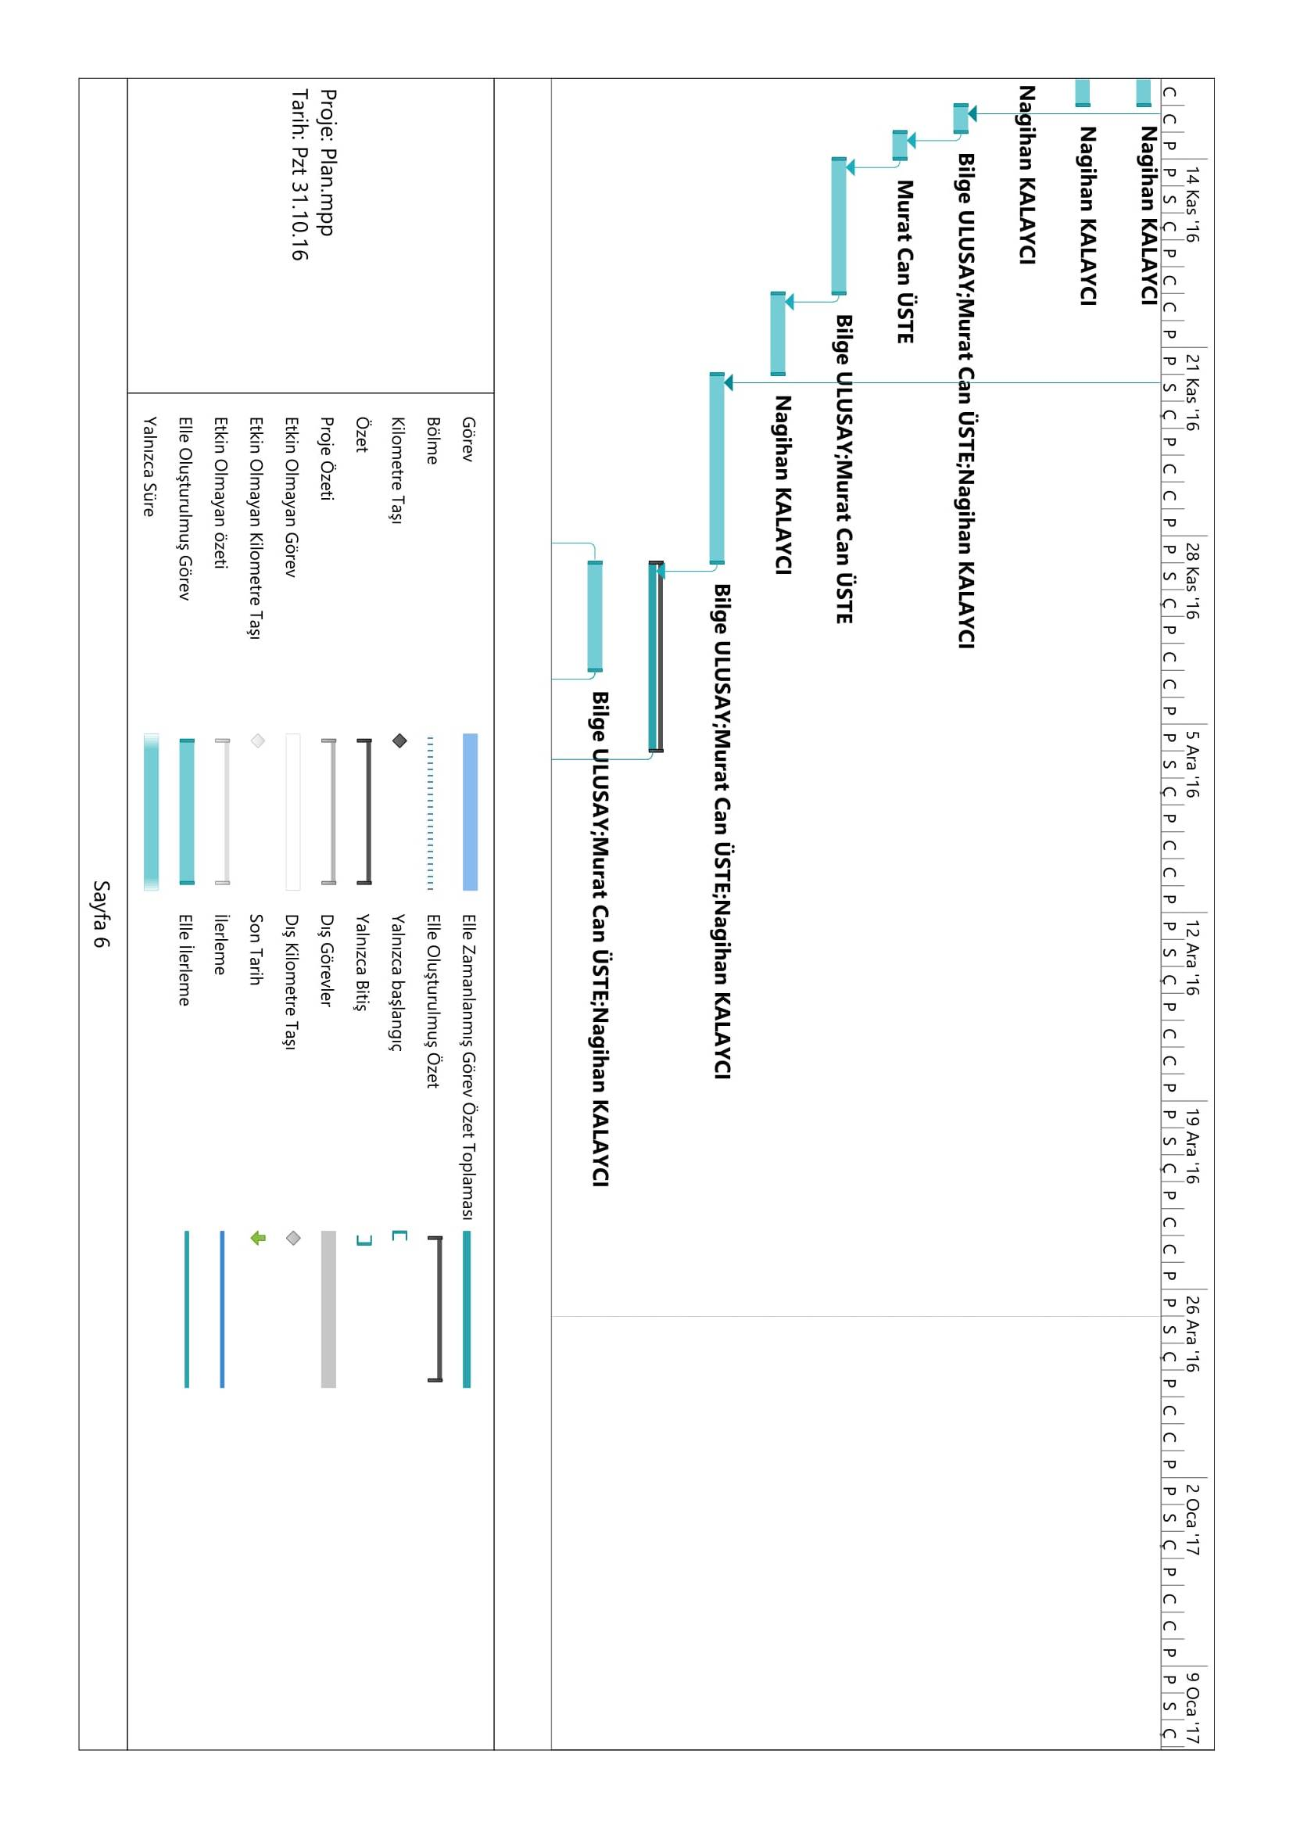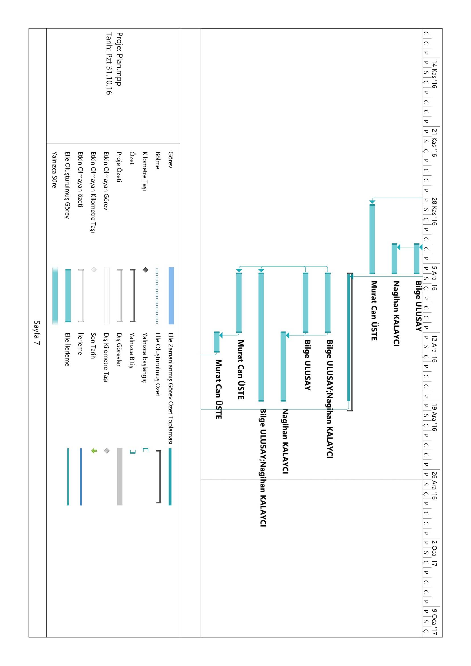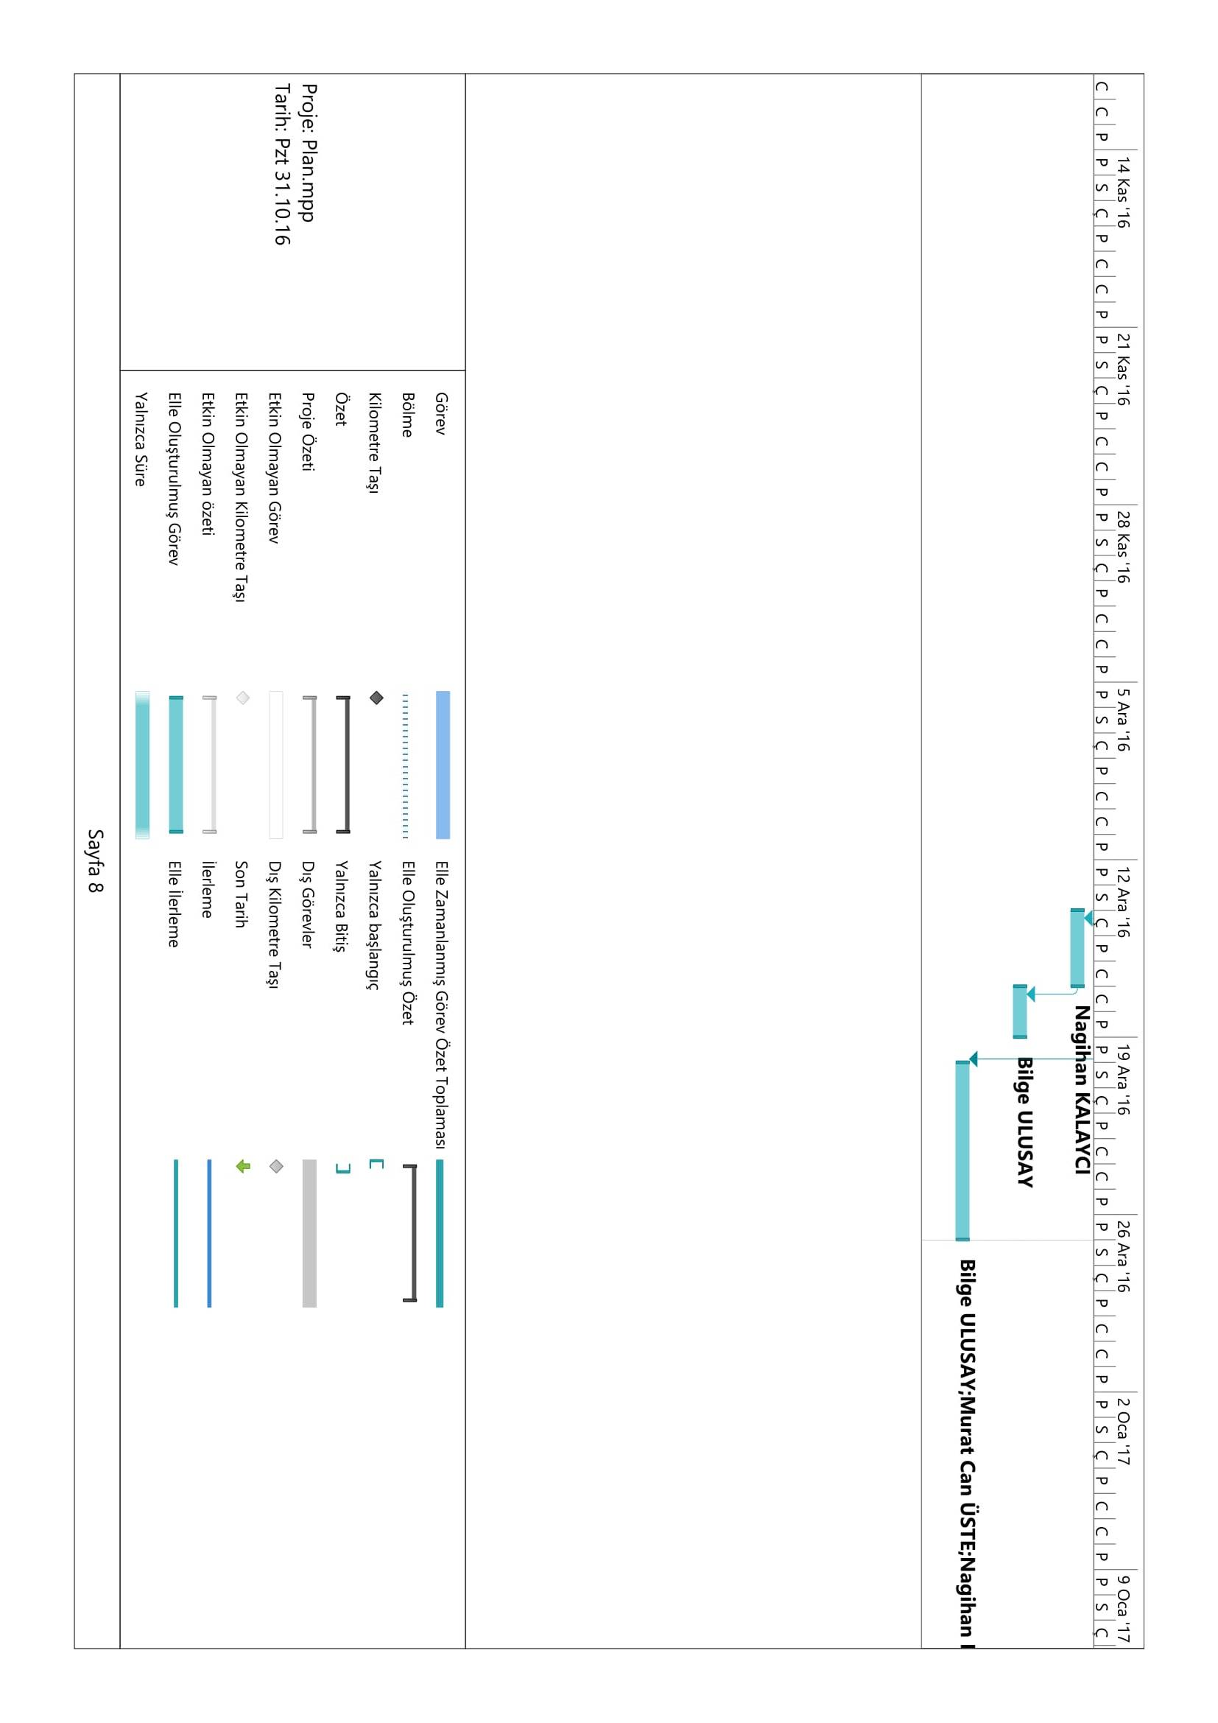

**2. Network Diagram of the Project Plan**

*Overview*

**

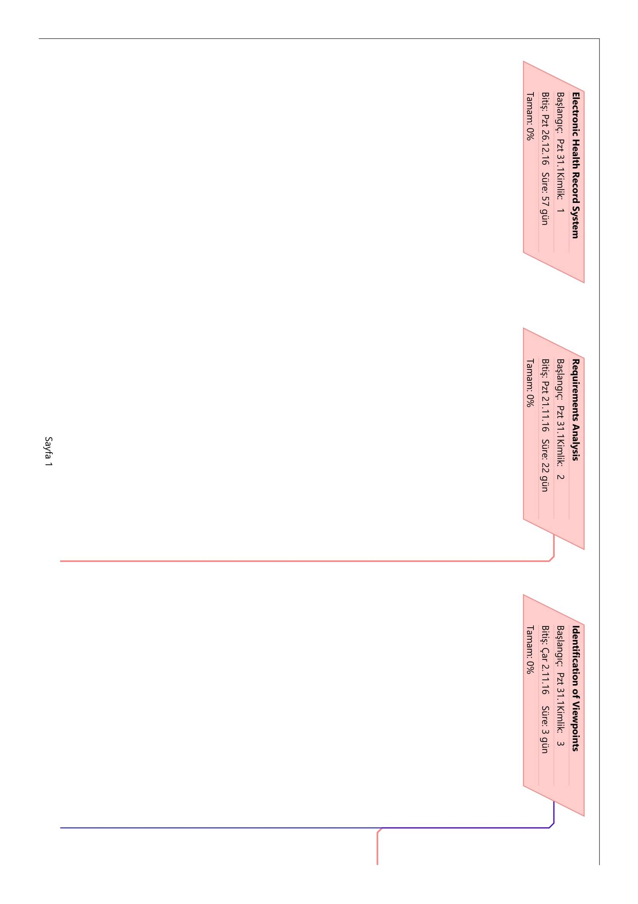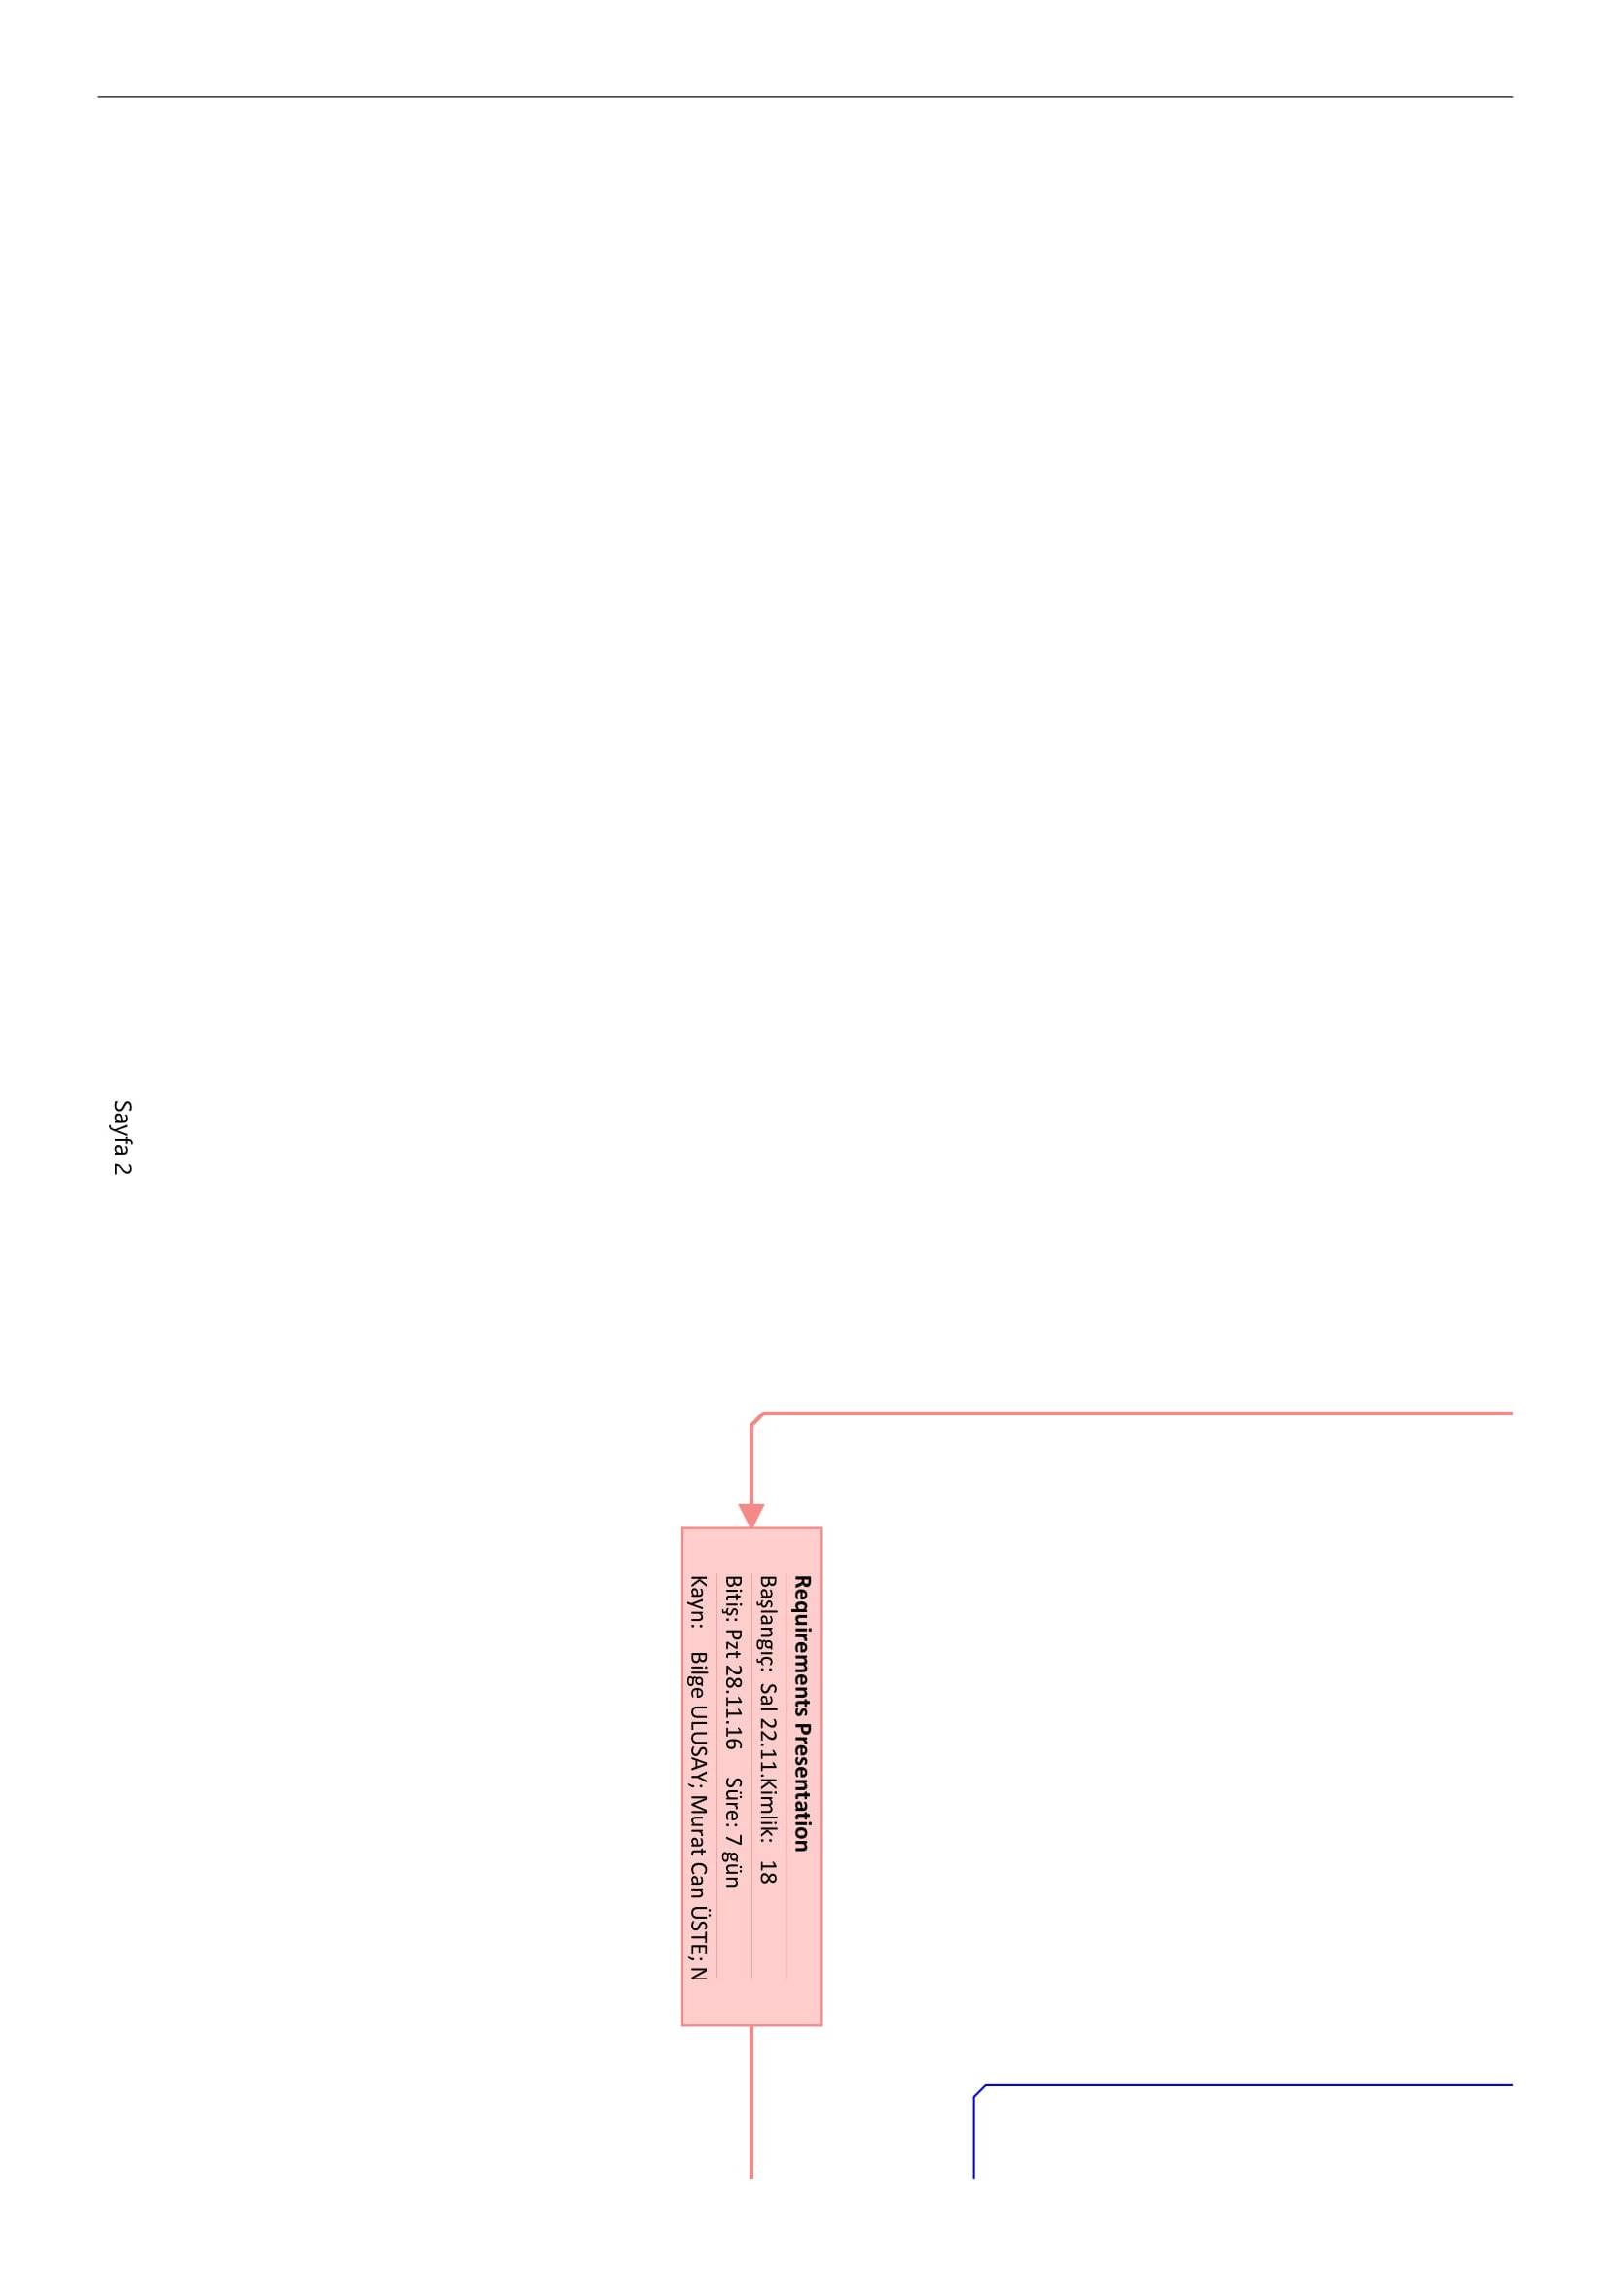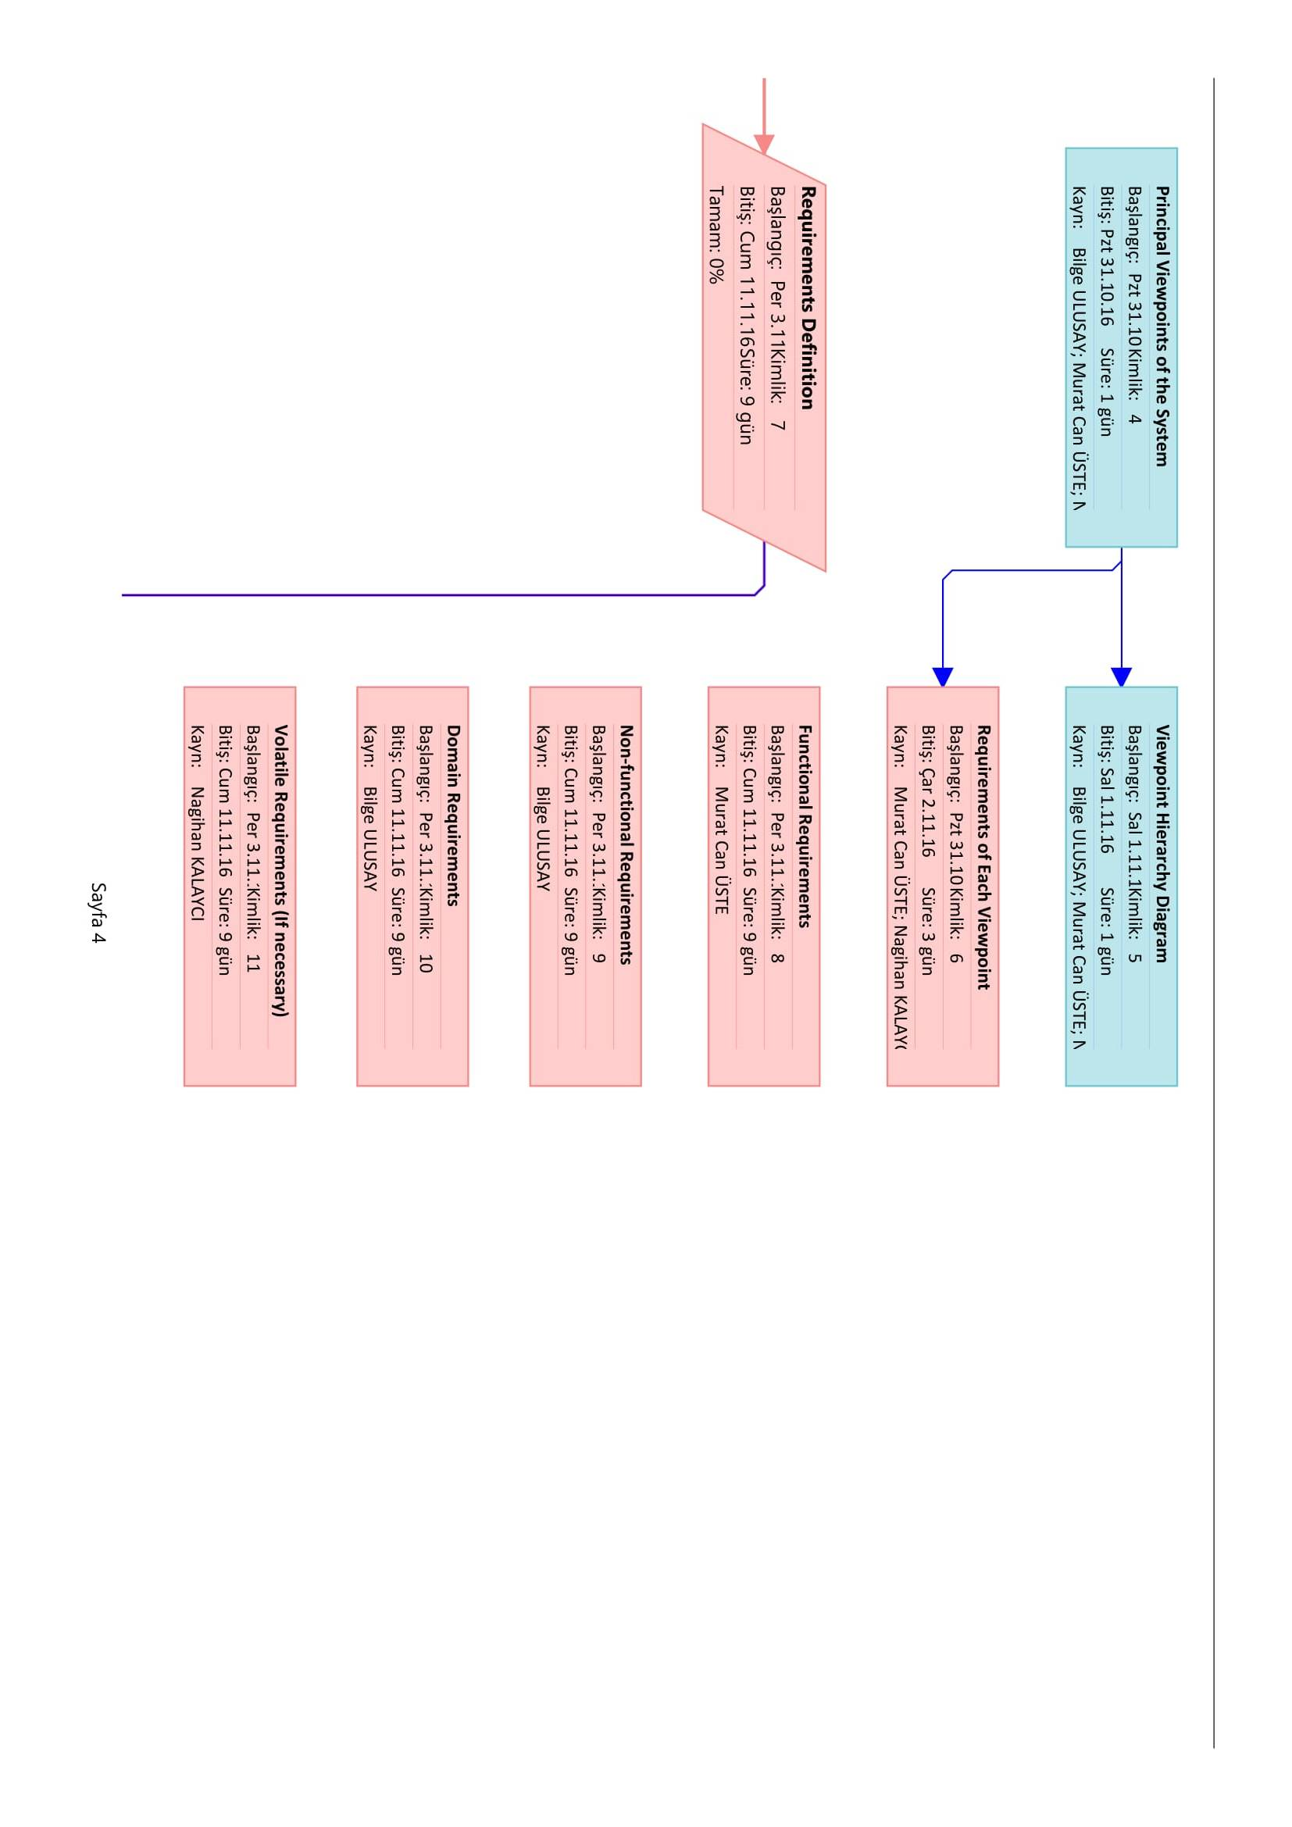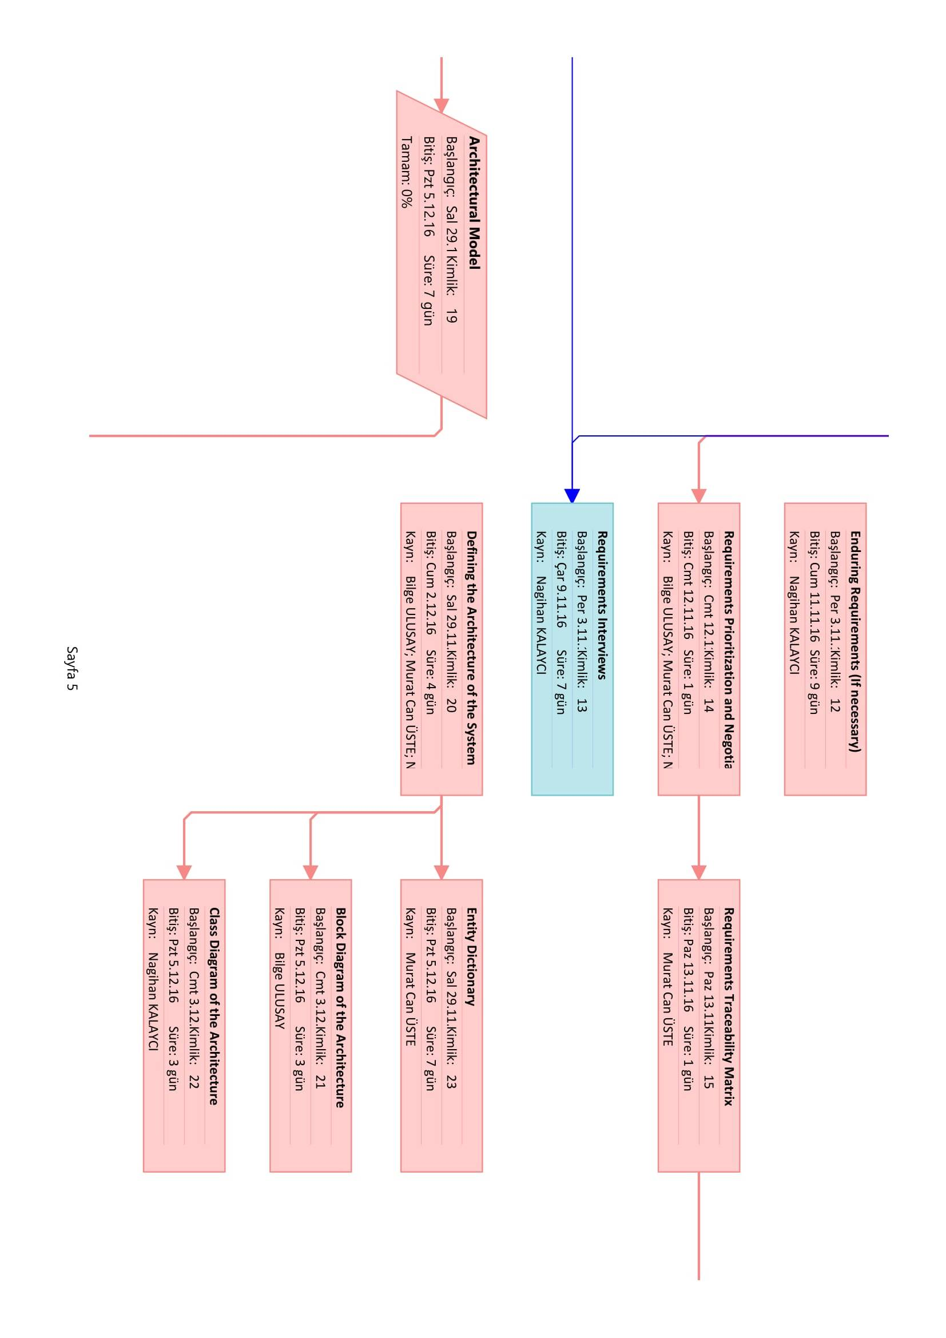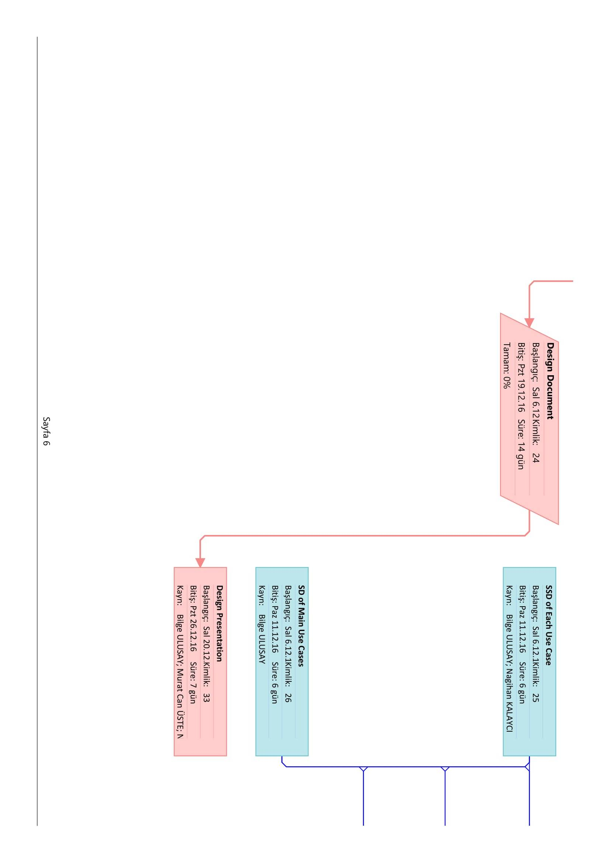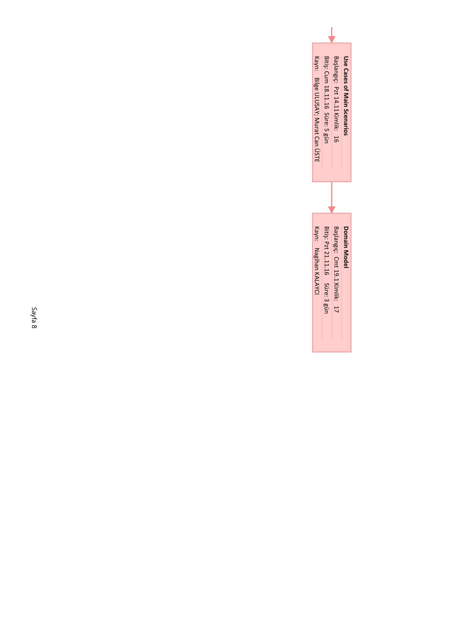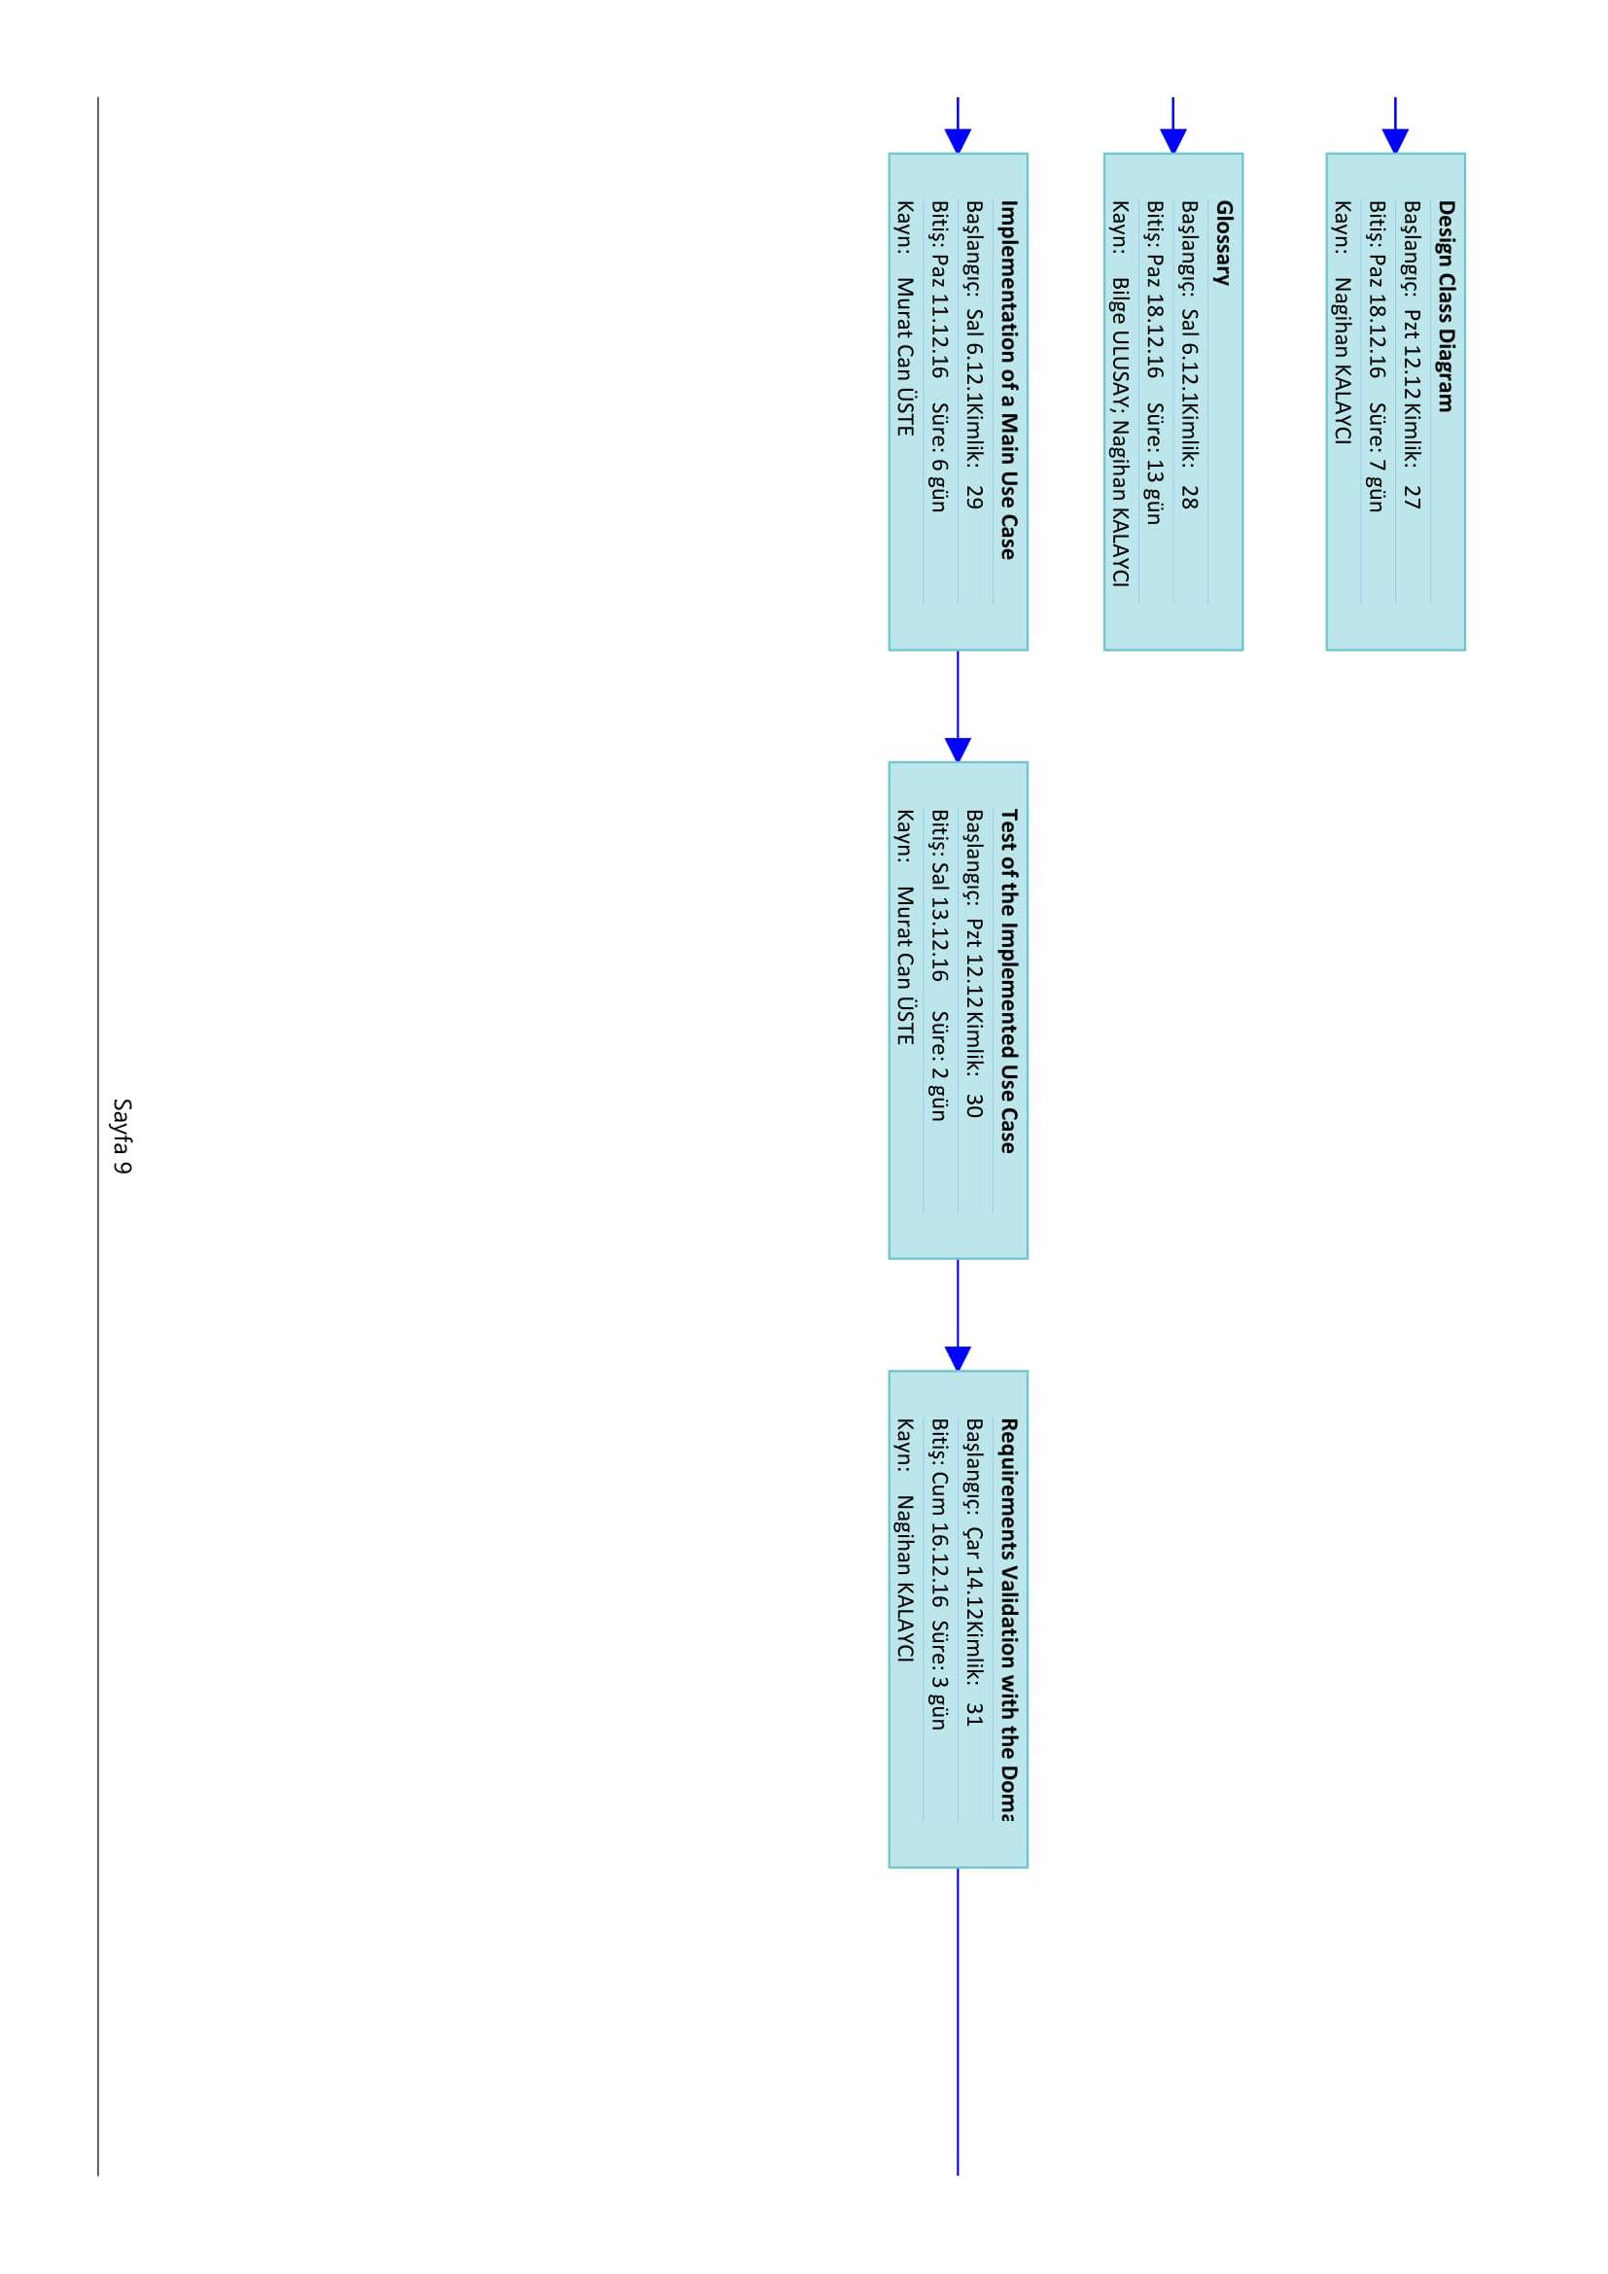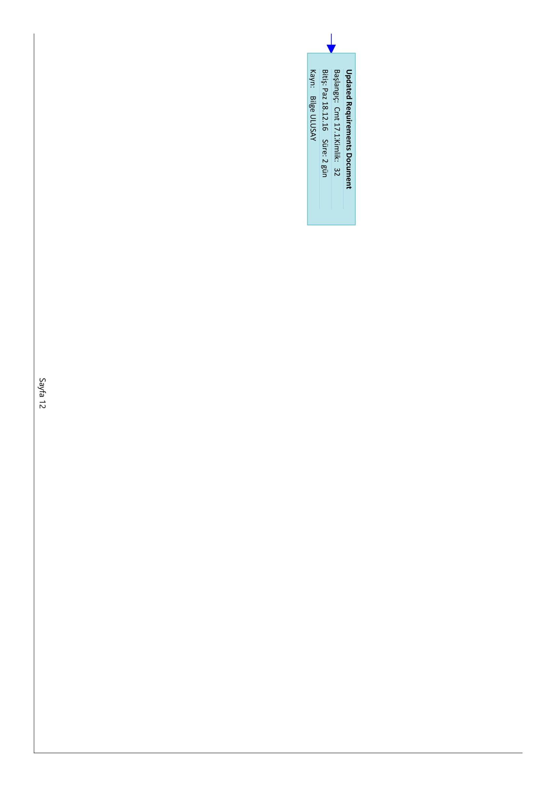

**3. Division of Labor within the Team**

*Overview*



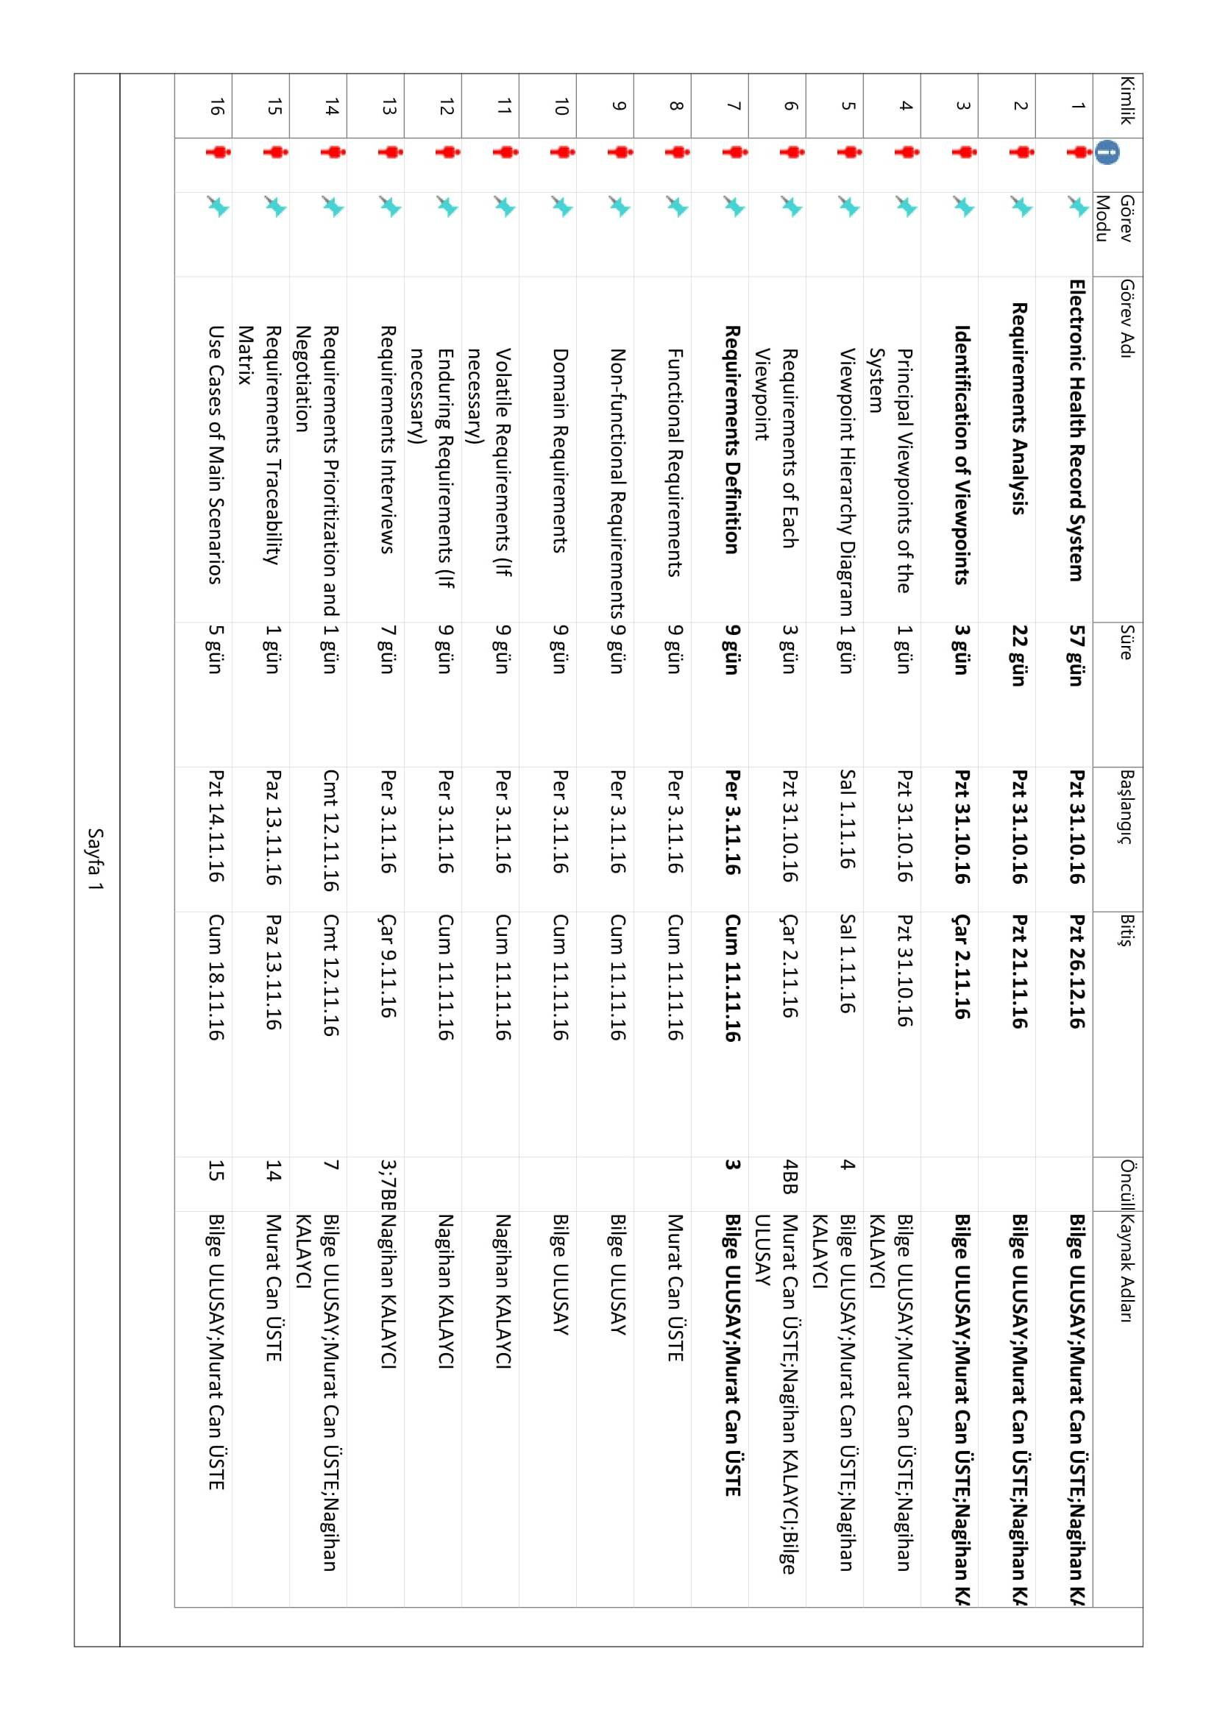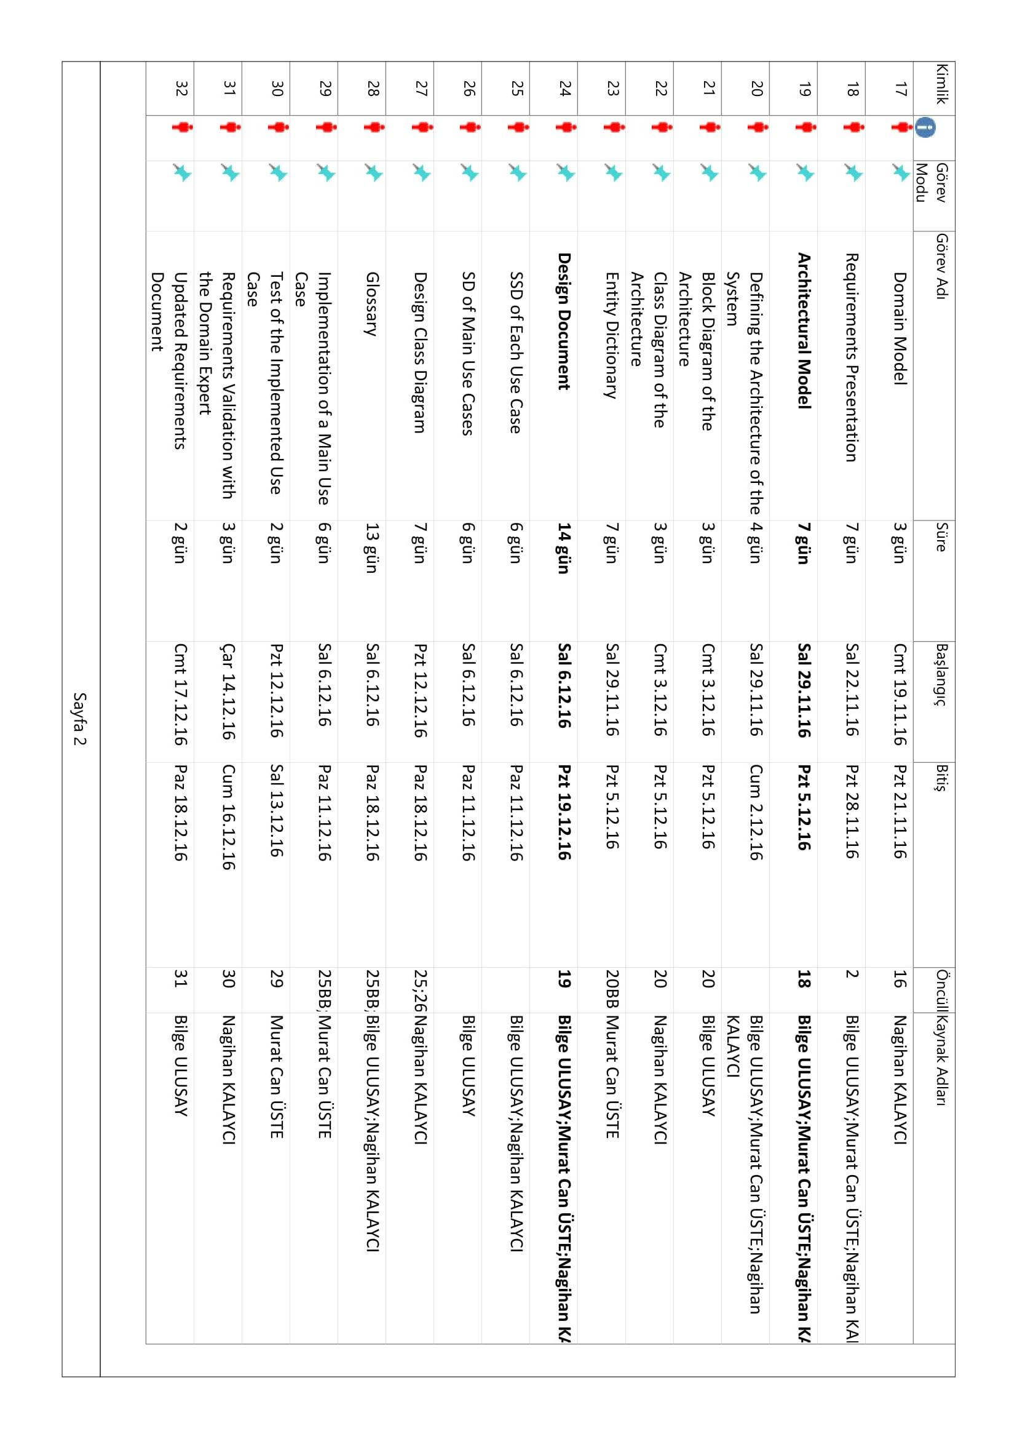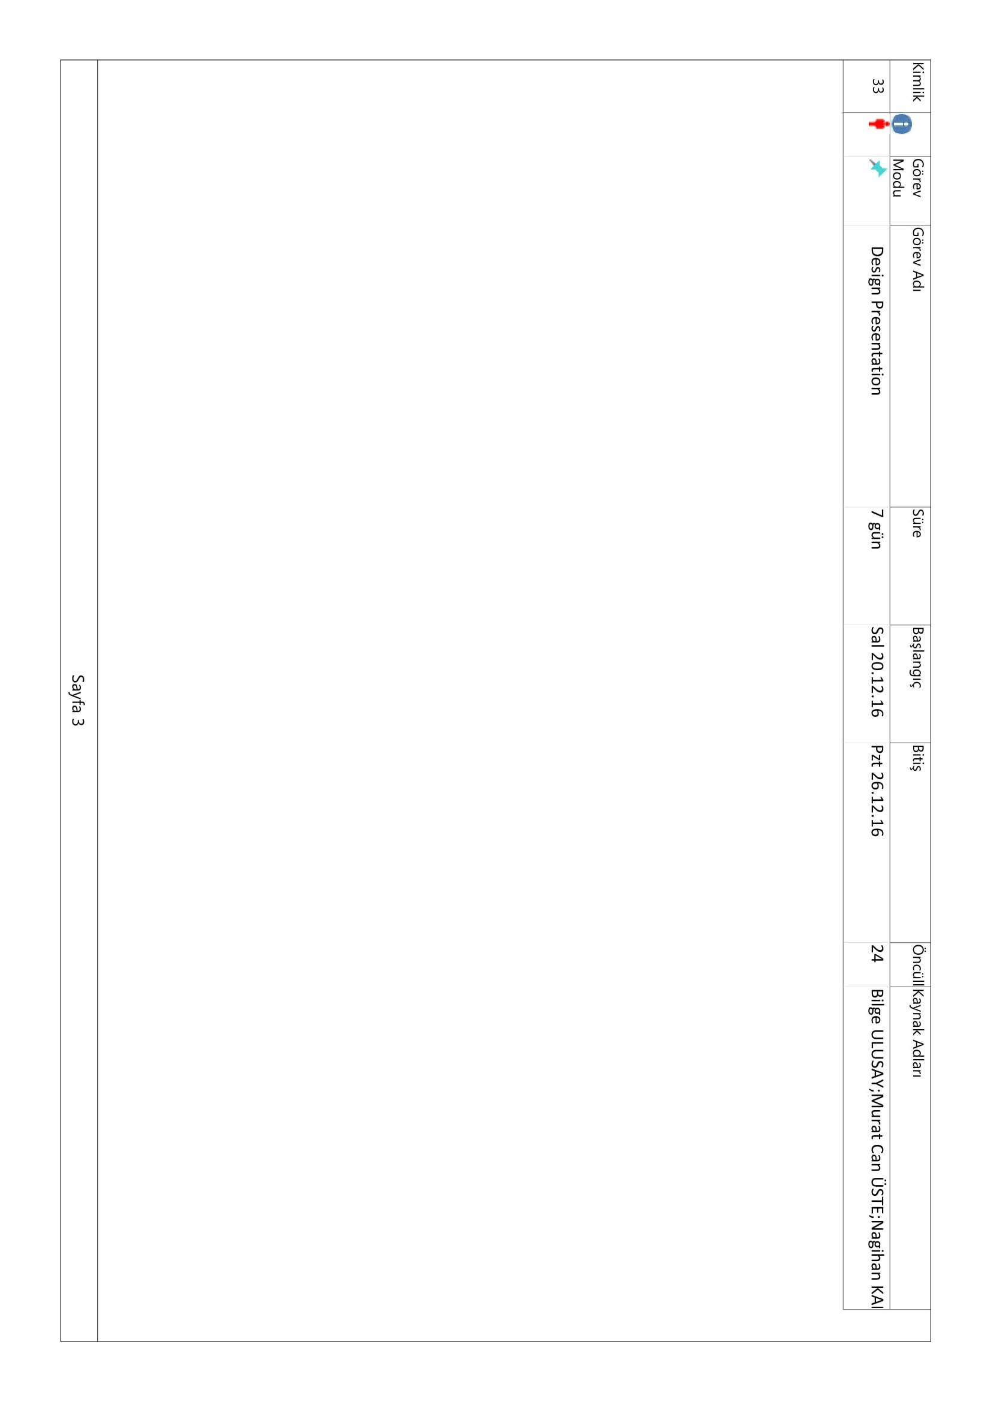

**3. Risk Analysis**

|  |  |
| --- | --- |
| Risk | Description |
| Hard-to-reach requirements | Backup and restore may require the inclusion of additional third-party products |
| Unsatisfying knowledge | The lack of scientifically relevant sample data impacts team's ability to validate the product |
| Insufficient resource | There won't be a library to correspond software requirements |
| Financial problems | Requirement costs will be higher than expected |
| Communication problems | Customer requests may not be understood or team will lag behind the requests |
| Incompatible components | Dependent systems are incompatible during integration |
| The lack of qualified personnel | the lack of a sufficient number of talented developers to develop the project |
| The lack of hardware security | Hardware can often be “upgraded” with malicious firmware. |
| Interfaces Requirement for Internal Users | Staff within the organisation may need to access information or enter data into the system. You need to consider the display requirements and the data capture requirements for internal users. Typically the interface required for internal users is an on screen display or report. |
| Tool Requirements | Absence or replacement of essential tools |